28. Shopping Tour

Tour | Shopping Escort Tour
Min. | 3 People
Time | 18:00-22:00
Course | Hotel → Insadong → Myeongdong → Dongdaemun Market → Itaewon → Hotel
Cost | 70,000Won (per)
Condition | Guide, Transportation, Hotel pick up & Sending
Cancel | 70 % cancellation charge on tour day
Remark | Dongdaemoon market is closed on every Mondays.

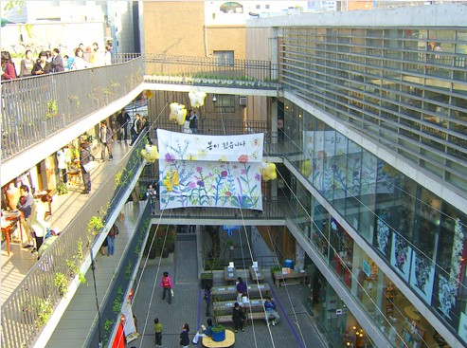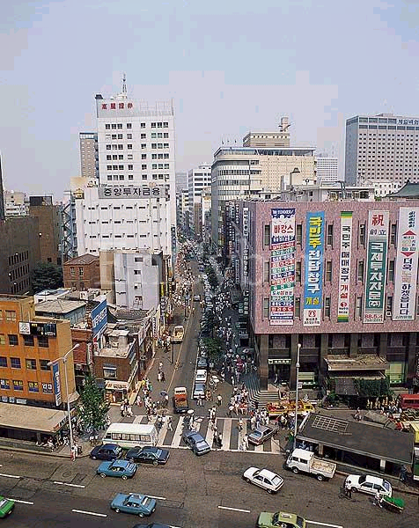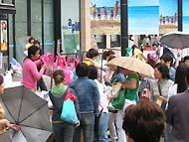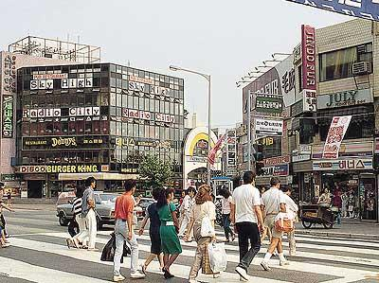

- Insadong

The street where you can feel traditional Korean culture, Insa-dong is the best place for those who want to experience Korean traditions. Numerous traditional teashops, galleries, antique shops and traditional restaurants are placed along the narrow alley.

- Myeongdong

Myeongdong Street covers a one kilometer area from Myeong-dong Station to Euljiro and Lotte Department Store. It is not too much to say that Myeong-dong is the busiest region in Seoul and is the leader in Korean fashion trends. Not only will you find large shopping malls and famous brand name shops where you can find clothing and shoes, but fast food chains, cozy cafes and specialty restaurants fill the alleys.

- Dongdaemun Market

Dongdaemun Market presents all kinds of goods ranging from small accessories to shoes and men"s and women"s wear at discounts of up to 20~30%.From hip-hop to traditional costumes, Dongdaemun is the biggest wholesale fation shopping center in Korea. The shops around Dongdaemun stadium sell various sport items at cheaper prices than elsewhere.

- Itaewon

Itaewon is where the cultures of east and west collide. It remains Seoul’s largest multicultural district and is a virtual magnet for shoppers on the hunt for styles and sizes reminiscent to what they would find back home. Everything from athletic apparel, outdoor hiking gear, luggage, tailor-made suits, accessories, and baseball caps to a dizzying array of antiques and traditional souvenirs - you can find it all here. And for a relatively cheaper price too.

