27. Romantic Night Cruise Tour

Tour | Romantic Night Cruise Tour
Time | 18:00-22:00
Min. | 3 People
Cost | 79,000won(per)
Course | Hotel → Han river Cruise→ 63 Building→Hotel
Condition | Guide, Transportation, Admission Fee,  Hotel pick up & Sending
Cancel | 70 % cancellation charge on tour day
1. All tour attraction in this journey is opened 24/7.
2. Cruise schedule is flexible according to unexpected weather status or local site circumstance on tour day.

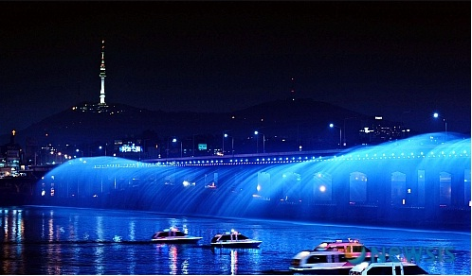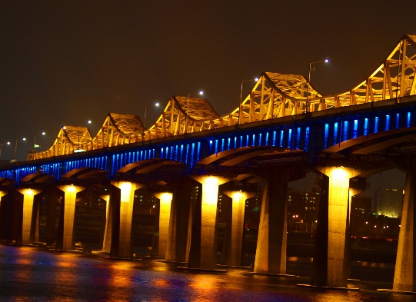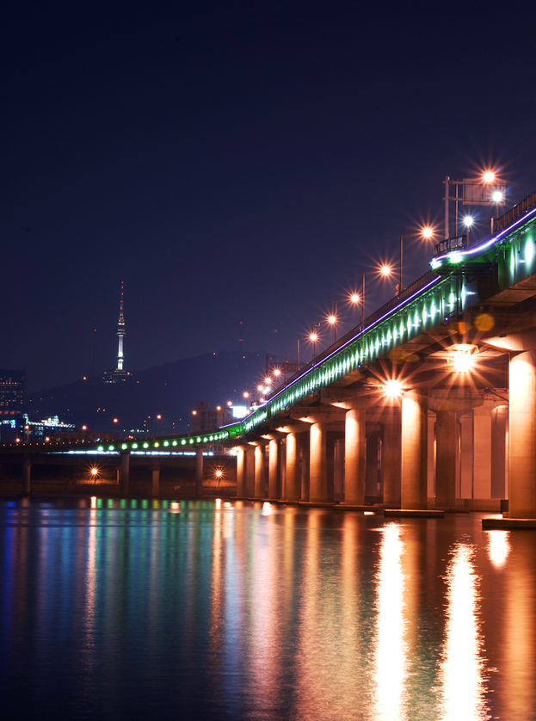
- Han river cruise
The Cruise in Han River through metropolitan city.
- 63 Building

The 63 Building, officially the 63 City, is a skyscraper on Yeouido island, overlooking the Han River in Seoul, South Korea.

