10. Special City Night Tour

Tour | 넫Special City Night Tour
Time | 18:00-22:00
Min. | 3 People
Cost | 82,000won(per)
Course | Hotel → Namsan Nanok Village→ N Seoul Tower→ Myeongdong→Cheonggye Stream→Hotel
Condition | Guide, Transportation, Admission Fee,  Hotel pick up & Sending
Cancel | 70 % cancellation charge on tour day
Remark | 1. Namsan Hanok Village is closed on every Tuesday and it will be replaced by Bukchon Hanok Village.  2. N Seoul Tower Observatory is included. Cf) Cable Car is excluded.

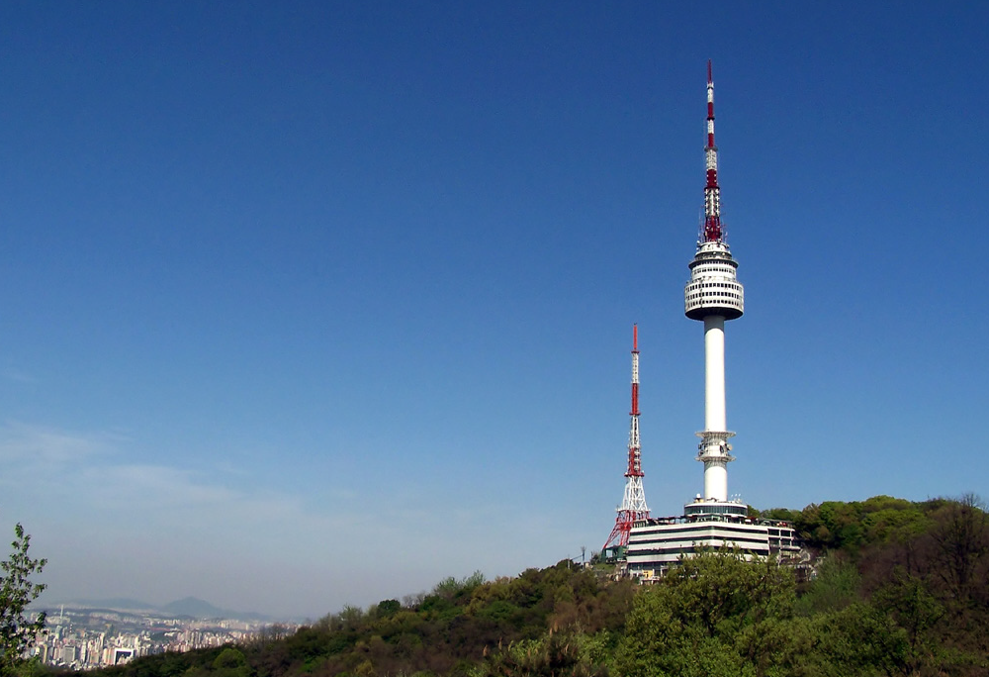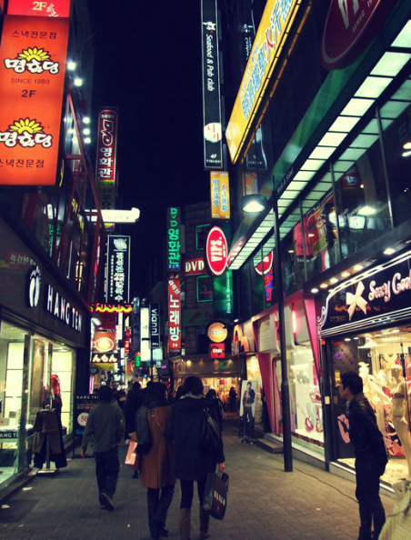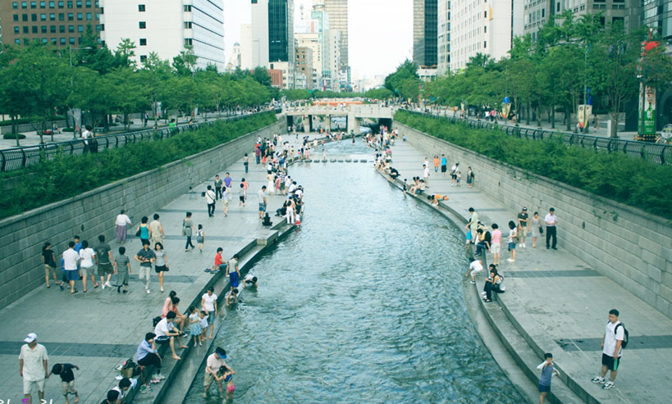
- Namsan Hanok Village
A folk village located in the middle of the city, more specifically, in the area called Pil-dong, at the foot of the northern part of Namsan. First opened to the public in 1997 after four-years of construction, the village has five authentic old Korean Hanoks that have been transported from other parts of the country and restored to perfection with traditional gardens, pavilions, and ponds. The village is also available for wedding ceremonies, which take place two or three times a week. Visitors can also view and purchase traditional ceramic arts and crafts in the exhibition hall.

- Seoul Tower
'N' from N Seoul Tower stands for New, Namsan and Natural Seoul Tower.
Most visitors ride the Namsan cable car up the mountain, and then walk to the tower. The tower features a gift shop and restaurants on the ground floor. Visitors may go up the tower for a fee. There are four observation decks (the 4th observation deck, which is the revolving restaurant, rotates at a rate of one revolution every 48 minutes), as well as gift shops and two restaurants. It is a popular place to go on clear days to see most of Seoul.

