12(A). D. M. Z. Tour

Tour | The Only Divided Country in the World!!  Witness and feel the tension of the Cold War that still exists today  at this site of the D.M.Z.
Time | Afternoon: 12:00-18:00
Min. | 1 Person
Cost | 55,000 Won(per)
Course | Hotel → Imjingak Park → ID check at Unification Bridge  → DMZ theater & exhibition hall → The 3rd Tunnel → Dora Observatory  → Dorasan Station → Amethyst or Ginseng Center → Drop off at Itaewon  * Passport is required.
Condition | Guide, Transportation, Admission Fee, Hotel pick up
Cancel | 70 % cancellation charge on tour day
Remark | 1. DMZ Tour is closed on Mondays and National Holidays.  2. Tour can be canceled according to unstable weather status of the tour day or unexpected situation which is able to be happened in DMZ.

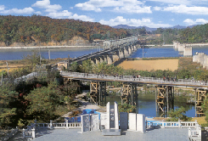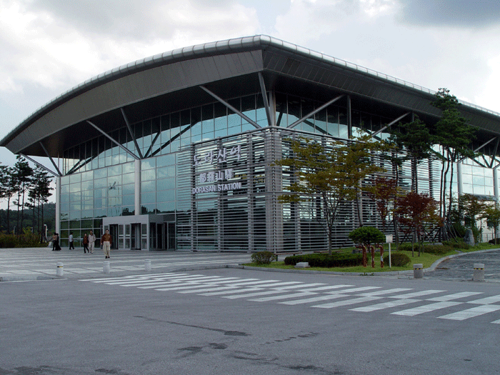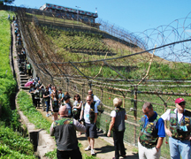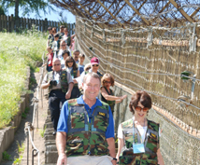

- Imjingak Park

Imjingak tourist sites are the place where the Korean war was broke out on 25 June 1950 and one race has been opposed to each other. There are diverse monuments in this place; a war record monument of Imjingak district, a monument of America’s entry into the war, a memorial tower of 17 diplomatic mission died by North Korean’s bomb terror in Myanmar in 1983, and a monument for people in Kimpo Airport bomb accident in 1987. Train used to travel to Sinuiju, where is located in the north end of the country, before the partition of the Korean Peninsula.
- The 3rd Tunnel

Only 44 kilometers or, less than an hour's drive, from Seoul, the third tunnel was discovered in October 1978. Almost identical in structure to Tunnel Ⅱ, the 1.635 kilometer-long tunnel, 1.95 meters high and 2.1 meters wide, penetrates 435 meters south of the Military Demarcation Line at a point only 4 kilometers south of the Truce Village of Panmunjom. It runs through bedrock at a depth of about 73 meters below ground. Capable of moving a full division per hour, plus their weapons, it is evidently designed for a surprise attack on Seoul.

- Dora Observatory

52 years of anticipation, waiting for the day when the two countries will be united once again. Dorasan station, the northernmost station in South Korea, has planned to connect the Gyongueisun(Line) and it will be linked to the European continent via the Siberian Railway.

- Dorasan Station

52 years of anticipation, waiting for the day when the two countries will be united once again. Dorasan station, the northernmost station in South Korea, has planned to connect the Gyongueisun(Line) and it will be linked to the European continent via the Siberian Railway.

Reservation
Address President Hotel #309 188-3 1(il)ga Eulji-ro Joong-gu, Seoul, Korea 100-191
Homepage http://cosmojin.com/eng/
Tel +82-2-318-0345(Eng. Jap.), +82-2-318-0425(Chin.)
Email cosmojin@cosmojin.com

