4. Korean Cultural Insight Tour

Tour | The history and modern culture of Korea live together
Min. | 1 Person
Time | 13:00-17:30
Course | Hotel → Changdeok Palace → Amethyst or Ginseng Center  → Insadong → Namdaemun Market → Hotel
Cost | 40,000 Won(per)
Condition | Guide, Transportation, Admission Fee, Hotel pick up & Sending
Cancel | 70 % cancellation charge on tour day
Remark | 1. Changdeok Palace is closed on Mondays and it will be replaced by another tourist attraction.

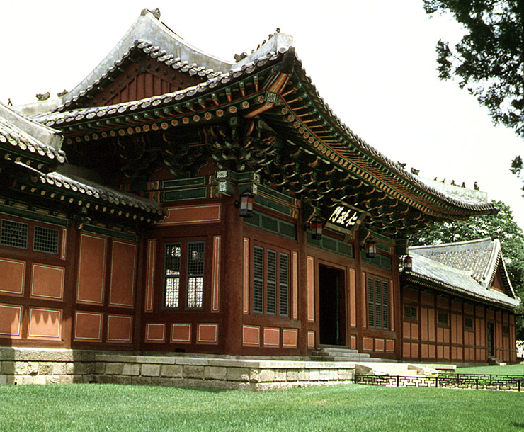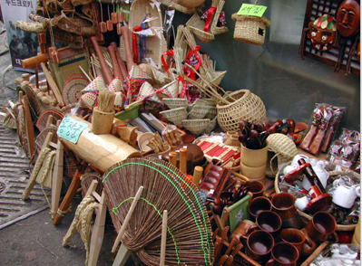

- Changdeok Palace

Changdeok Palace was built during the 5th year of the reign of King Taejong (1405) as a royal villa. It was later used as royal residence when Gyeongbok Palace was burnt down during the Japanese invasion in 1592. Since the site of the Palace is not level, the layout of the buildings is designed in such a way that architectural forms adapt to the changing natural terrain.

- Insadong

The street where you can feel traditional Korean culture, Insadong is the best place for those who want to experience Korean traditions. Numerous traditional teashops, galleries, antique shops and traditional restaurants are placed along the narrow alley.

- Namdaemun Market

Namdaemun Market is the largest one in Seoul and shoppers may get any product in Korea at the cheapest price at here. Moreover it’s near from the center of Seoul, passengers can easily access to the major hotels even at night.

Reservation
Address President Hotel #309 188-3 1(il)ga Eulji-ro Joong-gu, Seoul, Korea 100-191
Homepage http://cosmojin.com/eng/
Tel +82-2-318-0345(Eng. Jap.), +82-2-318-0425(Chin.)
Email cosmojin@cosmojin.com

