1. Gyeongbok Palace

Tour | The history and modern culture of Korea live together
Min. | 1Person
Time | 09:00-12:30
Course | Hotel → Jogye Buddhist Temple→ The Royal Guard Changing Ceremony  → Gyeongbok Palace → The National Folk Museum  → Pass by the Presidential Blue House → Amethyst or Ginseng Center  → Drop off at Itaewon
Cost | 38,000 Won(per)
Condition | Guide, Transportation, Admission Fee, Hotel pick up
Cancel | 70 % cancellation charge on tour day
Remark | 1. Gyeongbok Palace will be replaced by another tourist attraction when it is closed on Tuesdays.  2. The Royal Guard Changing Ceremony will be cancelled when it is rainy.

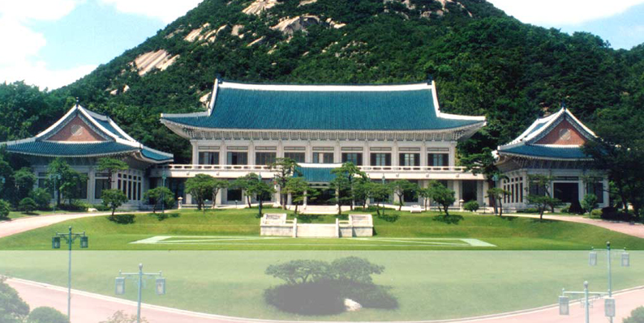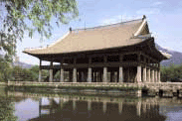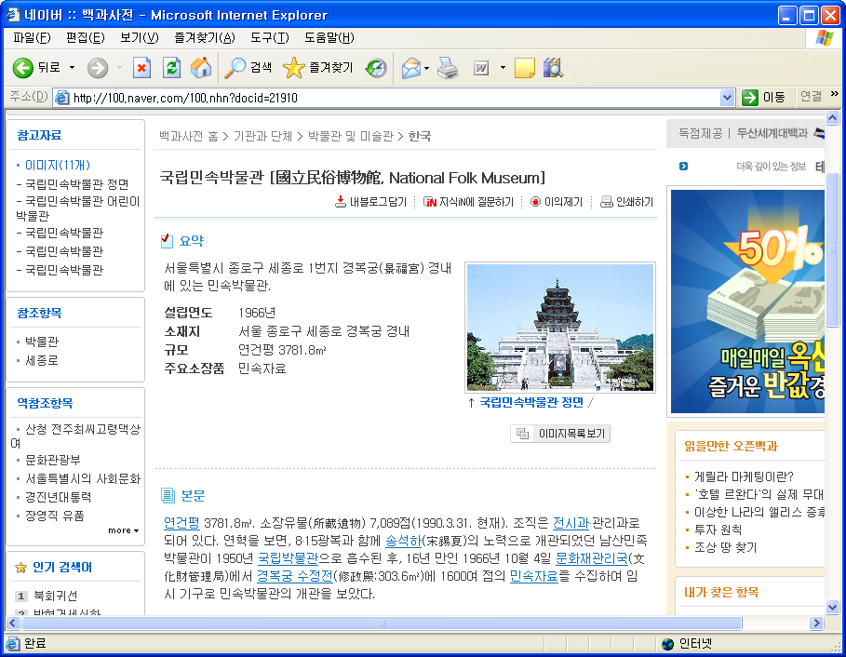

- JogyeTemple

JogyeTemple is located in the heart of Jongno, Seoul, a global community of international culture. Through full of modern developments it is also superbly positioned as a historical site revealing the past and present of Korean Buddhism. The JogyeTemple has become a significant site of prayer and practice for lay Buddhists, and a welcoming resting place for ordinary citizens.

- Gyeongbok Palace

The palace was originally constructed in 1394 by King Taejo and "Gyeongbokgung" was named by minister Jeong Do-jeon. Gyeongbokgung was continuously expanded during the reign of King Taejong and King Sejong the Great, but part of the palace was burnt down during the Japanese invasions of Korea (1592-1598).
During the regency of Daewon-gun in 1867, the buildings were reconstructed and formed a massive 330-building complex with 5,792 rooms. Standing on 4,414,000 square feet (410,000 square meters) of land, it was a symbol of majesty for the Korean people and the home of the royal family. In 1895, after the assassination of Empress Myeongseong by Japanese agents, her husband, Emperor Gojong left the palace and the imperial family would never return.

- The National Folk Museum

The National Folk Museum of Korea, located in Gyeongbokgung Palace, features aspects of both the traditional folk culture of ordinary people and that of the aristocracy, centering particularly on the Joseon Dynasty (1392-1910). Devoted to the study, collection, and preservation of folk artifacts, it is also a forum for social education on folk culture through exhibitions and classes, which are designed to provide a better understanding of traditional Korean culture.

- The Presidential Blue House

Cheong Wa Dae (translation: The House of the Blue Roof Tiles or the Blue House, Office of the President of the Republic of Korea) is the executive office and official residence of the South Korean head of state, the President of the Republic of Korea. Both the English and Korean names refer to the building's blue-green roof. The Korean name has the literal meaning "house of the blue roof tiles." Cheong Wa Dae is in fact a complex of buildings, built largely in the traditional Korean style with some modern elements.

Reservation
Address President Hotel #309 188-3 1(il)ga Eulji-ro Joong-gu, Seoul, Korea 100-191
Homepage http://cosmojin.com/eng/
Tel +82-2-318-0345(Eng. Jap.), +82-2-318-0425(Chin.)
Email cosmojin@cosmojin.com

