DETERMINING ACETABULAR CUP POSITION FOLLOWING TOTAL HIP REPLACEMENT

B. Jaramaz^{1,2}, L. J. Cassenti², T. J. Levison¹, C. Nikou¹, and A. M. DiGioia^{1,2}

Centers for Medical Robotics and Computer Assisted Surgery,
¹UPMC Shadyside Hospital, Pittsburgh, PA and
²Carnegie Mellon University, Pittsburgh, PA
5200 Centre Ave, Pittsburgh, PA 15232
branko@cor.ssh.edu, 412-623-2673

INTRODUCTION:
Postoperative radiographic measurements are frequently used as an evaluation tool following total hip replacement (THR) surgery, especially to measure acetabular cup orientation. However, measurements of cup alignment from postoperative x-rays after THR are typically inaccurate because of uncertain pelvic orientation (1). Accurate and reliable measurements of acetabular cup position following THR surgery help improve analysis of postoperative outcomes as these radiographic measurements are often used in clinical studies, in particular to relate the cup orientation to dislocation rates and polyurethane wear. These acetabular cup measurements may also help validate the accuracy of the tools used in surgical navigation procedures. Using a computer-enhanced technique of cup measurement, we have analyzed a series of postoperative radiographs to assess the variability of acetabular cup orientation measurements.

METHOD:
Postoperative radiographs were used and combined with the preoperative computed tomography (CT) scan and the geometric model of the acetabular cup to find the cup position in the pelvis. In order to perform correct x-ray measurements of cup orientation, spatial orientations of both pelvis and the acetabular cup are determined. The pose of the CT pelvis is varied until a "synthetic" X-ray generated from a preoperative CT matches the true X-ray (Figure 1). Then, by projecting a model of the acetabular implant onto the standard X-ray, the precise implant orientation is determined (2).

This process provides stable anatomic reference basis for acetabular implant measurements, and does not depend either on the position of the central x-ray beam or unknown rotation of the pelvis during x-ray acquisition. Alternative baseline measurement was obtained intraoperatively using HipNav system for image guided navigation in THR (3). HipNav reports the cup orientation in the same anatomic reference system, defined by the anterior iliac spines and pubis symphysis points on the pelvis.

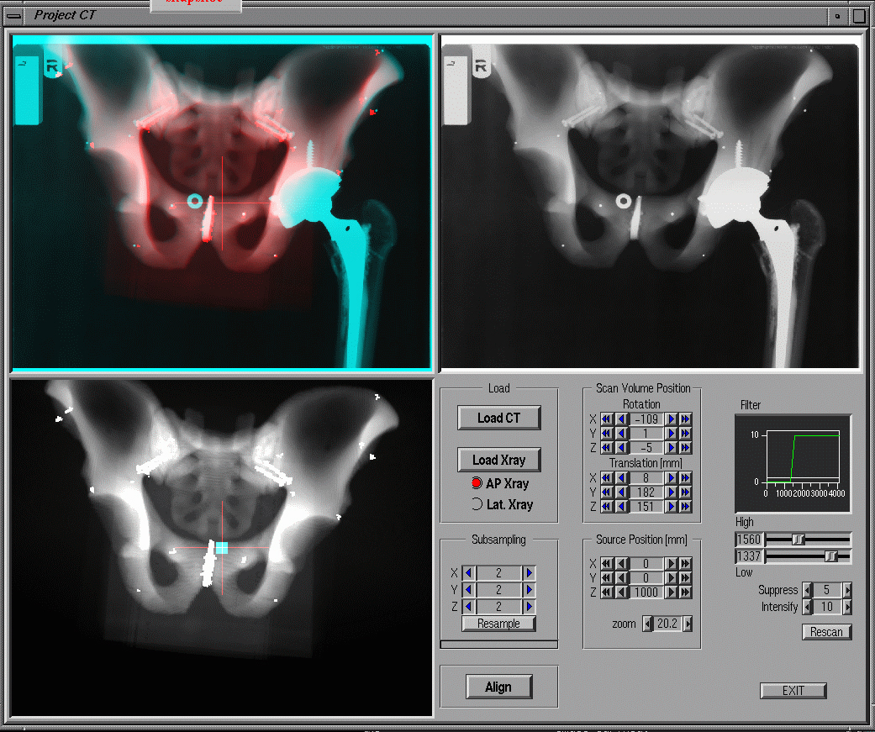
a
b
c
Figure 1. Xalign computer interface: a) synthetic x-ray; b) true x-ray; c) both x-rays overlaid

RESULTS:
We analyzed the anteroposterior (AP) radiographs acquired 1, 3, 6, and 12 months postoperatively following primary THR surgery for a group of HipNav patients. The CT scan is acquired preoperatively as a part of HipNav protocol, and used for preoperative planning and intraoperative guidance. The intraoperative measurement of the final cup alignment after pressfit was reported for every case. In some cases screws were inserted after that measurement for increased cup fixation. The x-rays are obtained in a supine position in a routine procedure without any special preparation, except for placing a marker at the position of the central x-ray beam. The range of cup abduction and flexion results was measured for each patient. The measurement of cup abduction per patient varied between 0.5° and 4.5° (mean = 2.1°, sd = 1.3). The measurement of cup flexion per patient varied between 0.8° and 3.1° (mean = 2.0°, sd = 2.2).
CONCLUSIONS:
These results confirm the accuracy of described methodology for measurement of implant alignment from regular x-rays. This methodology can be reliably used to analyze postoperative acetabular implant orientation and patient outcomes.

REFERENCES:
- Jaramaz B, DiGioia AM, Nikou C, Levison T: Variation in radiographically measured cup orientation, Fourth Annual North American Program on Computer Assisted Orthopaedic Surgery Proceedings, pg 167, Pittsburgh, PA, June 15-17, 2000.
- LaRose D, Cassenti L, Jaramaz B, Moody J, Kanade T, DiGioia A: Post-operative measurement of acetabular cup position using x-ray/CT registration, Medical Image Computing and Computer-Assisted Intervention- MICCAI, Third International Conference Proceedings, pp 1104-1113, Pittsburgh, PA October 2000.
- Jaramaz B, DiGioia AM, Blackwell M, Nikou C: Computer assisted measurement of cup placement in total hip replacement, Clinical Orthopaedics and Related Research, Vol 354, pp 70-81, September 1998.

